Output of My Portillo

1.When we run our program: -

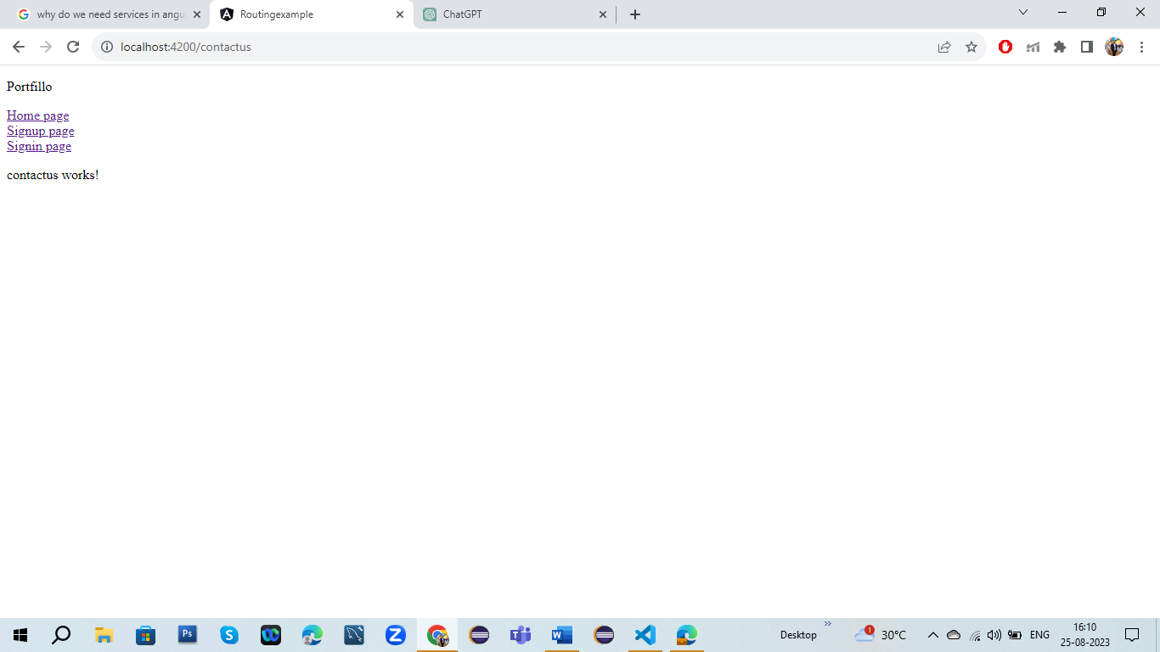

2.When We Click Home Page:-

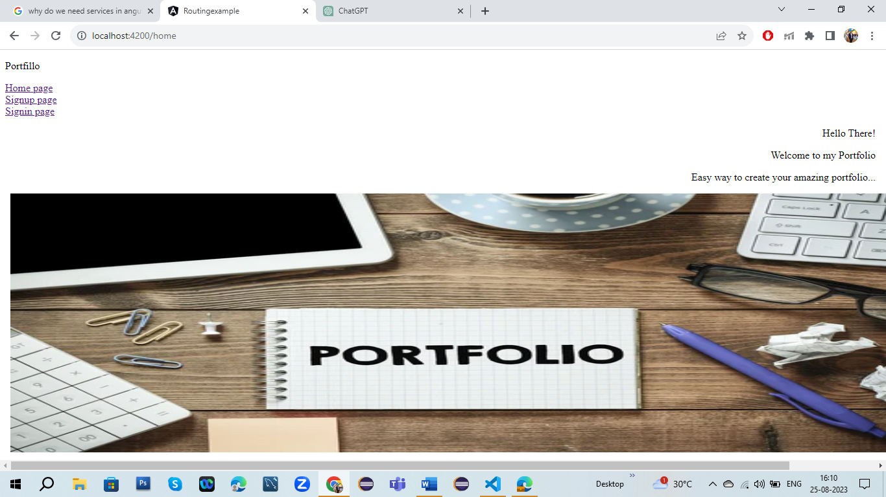

3.When We Click Signup Page:-

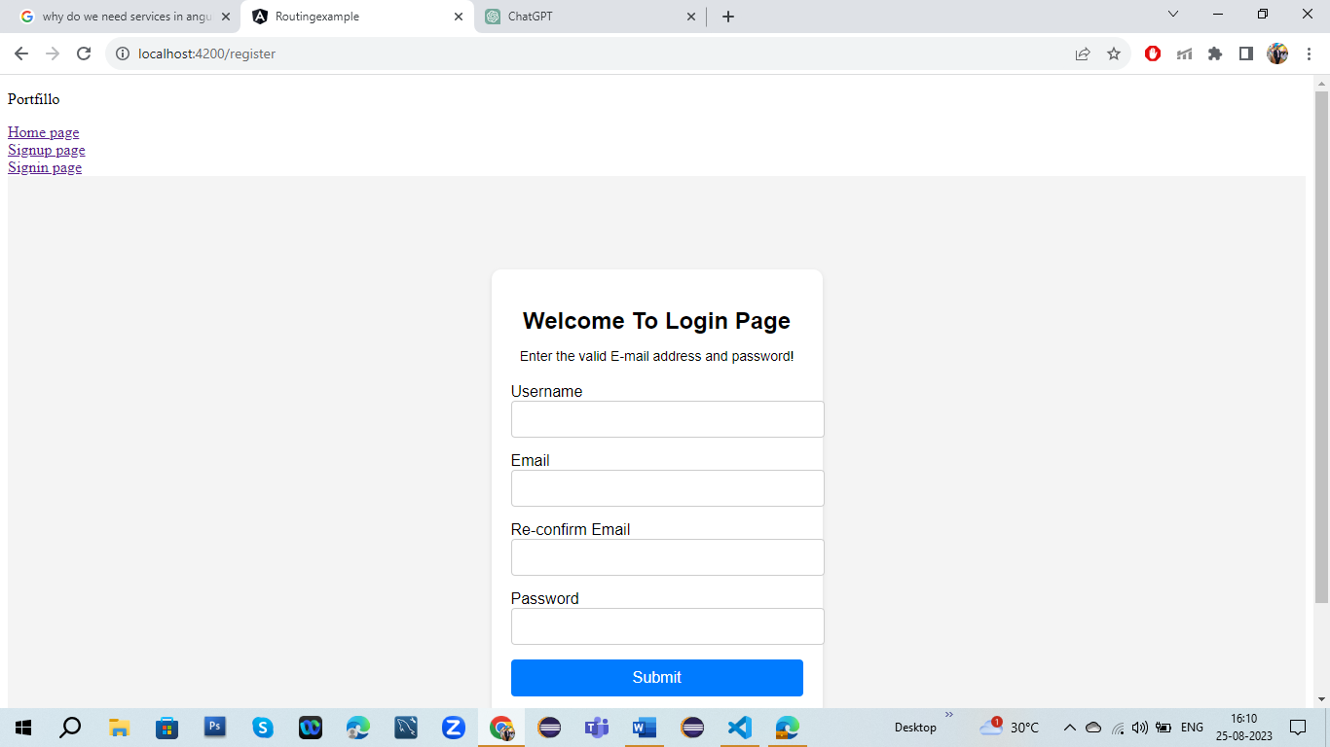

4.When we put all the details in signup page:-

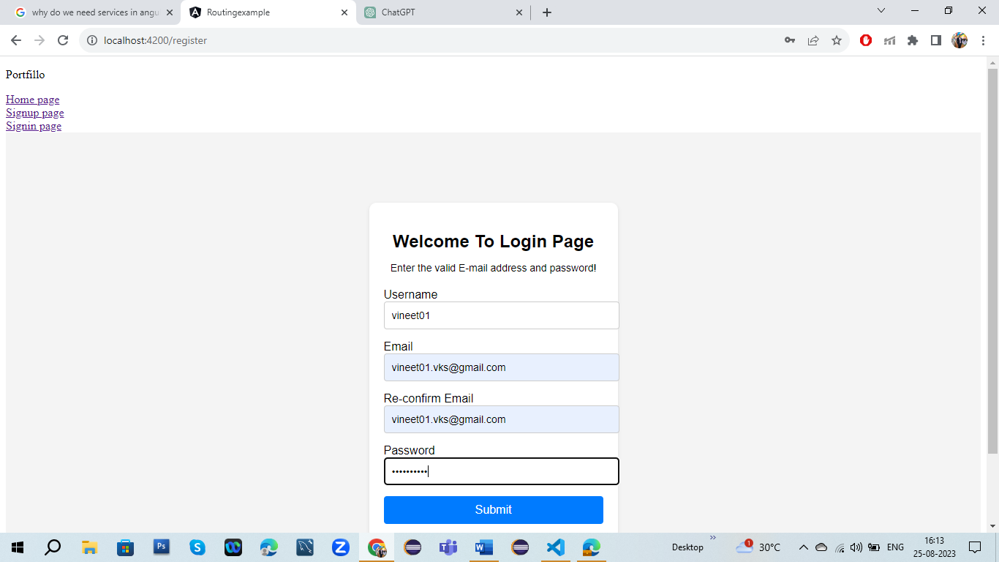

5.After signup then page will go to login Page:-

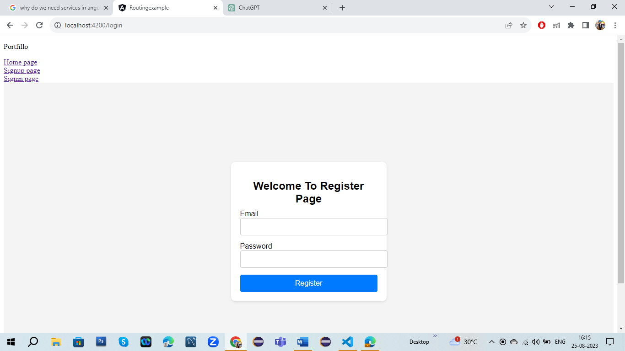

6.After putting all the details in login page:-

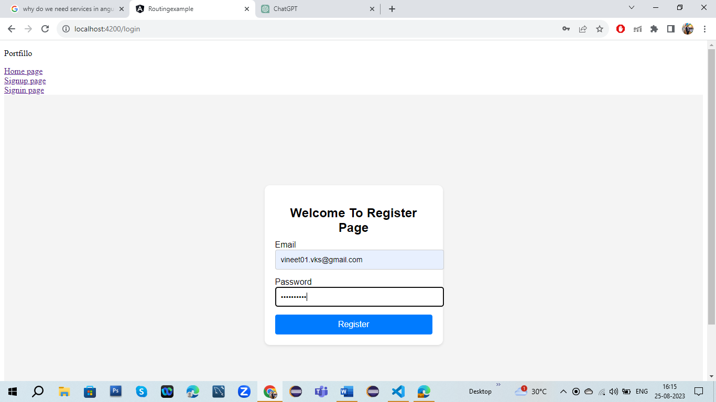

7.After Clicking register page will go to Landing Page: -

